**Documentation for Non – Fungible token**

**Overview:**

**Non-fungible tokens**

**NFTs** or non-fungible tokens are digital assets based on blockchain technology.Anything can become an NFT—a piece of art, sports memorabilia, or even a tweet.

**History:**

Non-fungible tokens have had a long history, since 2012 with the introduction of coloured coins built on the Bitcoin network. Since then, NFT have primarily moved to Ethereum, where non-fungible token standards such as ERC-721 and ERC-1155 can be minted and traded easily and seamlessly.

The first NFT collectibles that really took off in popularity were Rare Pepes. This was followed by CryptoPunks, and then arguably the most successful and well-known NFT project ever, CryptoKitties.

During the Ethereum boom of late 2017 and early 2018, NFT activity in CryptoKitties drove a huge spike in activity. When the market crashed in 2018, however, interest in NFTs was also impacted and stagnated until late 2020, when NFT saw resurgence with the resurgence of CryptoPunks, and newer projects like Hashmasks, Axie Infinity, and NBA Topshots.

**Father of NFT:**

British computer scientist Tim Berners-Lee is selling the source code for the World Wide Web as an NFT.

**What was the first NFT price?**

The first-ever NFT, Kevin McCoy's "Quantum," was auctioned this morning for **$1.47 million**, about half an hour after one of 10,000 CryptoPunks sold to betting-technology billionaire Shalom Meckenzie for $11.75 million.

**Who owns the most NFT?**

Almost exactly a year ago, **Sundaresan** bought the world's most expensive NFT and the third most expensive piece sold by a living artist. His $69.3 million purchase of Beeple's historic “Everydays: The First 500 Days” shocked the industry and was, at least in part, responsible for propelling NFTs into the mainstream

**Purpose of NFT:**

NFTs (non-fungible tokens) are unique cryptographic tokens that exist on a blockchain and cannot be replicated. NFTs can represent real-world items like artwork and real estate. "Tokenizing" these real-world tangible assets **makes buying, selling, and trading them more efficient while reducing the probability of fraud**.

**How NFTs Work:**

NFTs are created through a process called minting in which the information of the NFT is published on a blockchain. At a high-level, the minting process entails a new block being created, the information of the NFT being validated by a validator, and the information being recorded. This minting process often entails incorporating smart contracts that assign ownership and manage the transferability of the NFT.

As tokens are minted, they are assigned a unique identifier directly linked to one blockchain address. Each token has an owner, and the ownership information (i.e. the address in which the minted token resides) is publicly available. Even if 5,000 NFTs of the same exact item are minted (i.e. general admission tickets to a music festival), each of the tickets has a unique identifier and can be distinguished from one another.

**Is NFT a blockchain technology?**

**NFTs exist on a blockchain**, which is a distributed public ledger that records transactions. You're probably most familiar with blockchain as the underlying process that makes cryptocurrencies possible. Specifically, NFTs are typically held on the Ethereum blockchain, although other blockchains support them as well

**Which blockchain is best for NFT?**

**Ethereum**. Despite mounting competition, Ethereum remains the most popular NFT blockchain. The reasons are abundant: as a highly decentralized blockchain, it provides all the financial and legal services one typically needs for transactions without requiring intermediaries.

**Types of NFT:**

**1. PFPs and Avatars**

**Overview:**

Without a doubt, this format is what most internet users outside the NFT sphere think of when they think of NFTs. And that’s by design — a quick search of ‘NFTs’ on Twitter will net you a sea of tweets from users with avatars consisting of Bored Apes, CryptoPunks, Cool Cats, Doodles, and all their offshoots and spinoffs.

**NFT examples to inspire you:**

Owners of a PFP or avatar NFT are free to use them on their own social media profiles, most often as a digital flex. All that online flexing comes with one significant benefit to the broader NFT community: they’re essentially free ads for NFTs. Since the NFT boom of 2021, several celebrities have added PFP NFTs on their social media profiles. Even artists like BLOND:ISH have showcased their PFP NFTs on their Spotify profiles.

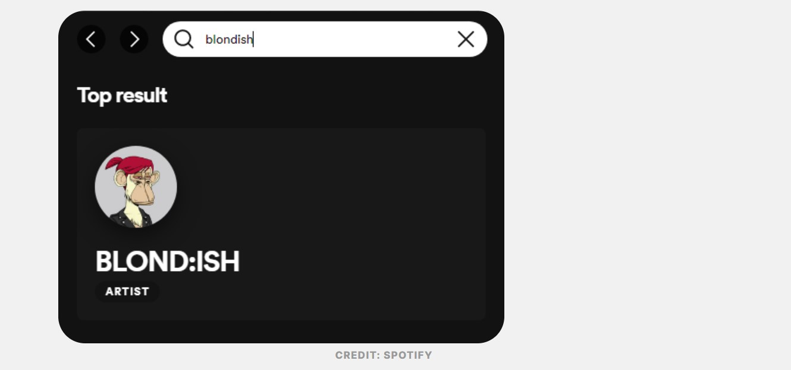

**2. One-of-one (1/1) artwork**

**Overview:**

During the minting phase of NFTs, creators can split up their work into multiple editions that may only differ on the blockchain end of things. This means different editions of the same piece may appear identical to each other visually, but possess different edition numbers or token IDs.

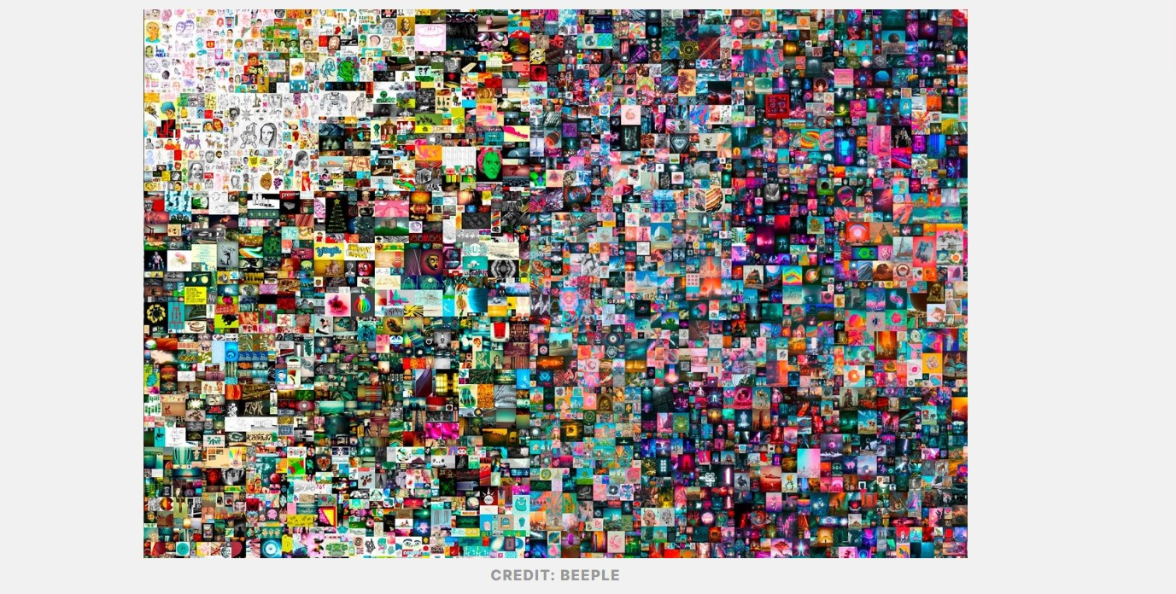

**NFT examples to inspire you:**

While this is great for increasing an artist’s work availability, some creators opt to go the exact opposite route and mint their work as a one-of-one NFT. Going this route means only one person may own the piece at any given time, inherently giving it more value on the open market. As evidenced by artists like Beeple, XCopy, and Pak raking in millions from their 1/1s, this strategy makes the most sense for creators hoping to utilize the scarcity imposed by NFTs on digital goods to their advantage.

**3. Generative art**

**Overview:**

Generative art is exactly what it sounds like — art that a computer has generated in some way. While often created by a generative algorithm or artificial intelligence (AI), some works created by physical robots also fall under this definition.

**NFT examples to inspire you:**

Generative art has experienced a renaissance and market boom due to NFTs, with projects like Art Blocks, Autoglyphs, and Braindrops pushing the envelope for the art form. Some projects are using generative art to create NFT merchandise for writers, giving them a solid entryway into the space.

**4. Collectibles**

**Overview:**

The recent boom of the sports trading card and memorabilia market hasn’t just happened IRL. It’s also taking place online, as evidenced by projects like NBA Top Shot. Despite that project’s well-documented rise and fall, collectibles remain a viable format for NFT projects, especially when they’re related to already-popular IP.

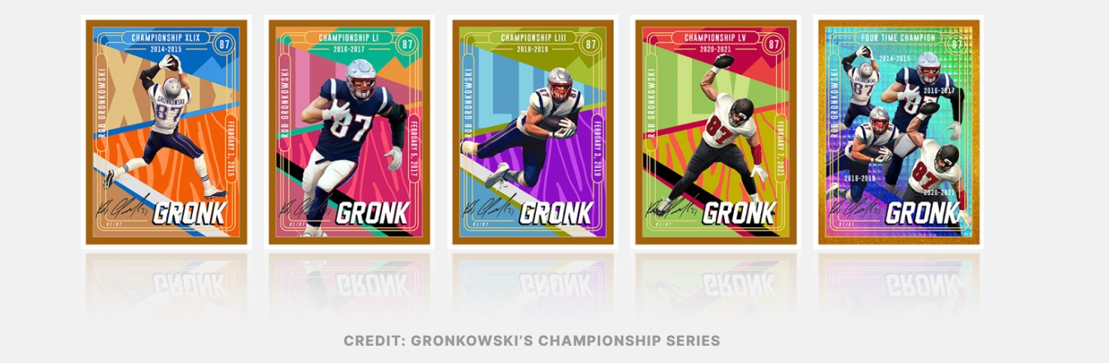

Just like their real-world counterparts, NFT collectibles can have varying degrees of rarity, and thus value. This makes them attractive to enthusiasts and collectors alike, who’d fork over a pretty penny in the pursuit of completing their collections.

**5. Photography NFTs**

**Overview:**

Photography NFTs are growing in popularity, and are poised to see continued growth in 2022 as more established photographers hop aboard the platform.

**NFT examples to inspire you:**

Thus far, we’ve seen photographers like Julie Pacino, Justin Aversano, and J.N. Silva find success plying their trade in the NFT space. As this segment of NFTs continues to grow, we expect to see more creators incorporating photography with other creative disciplines to explore the previously uncharted creative territory in the space.

**6. Music NFTs**

**Overview:**

At this point, most people are aware of the music industry’s failure to provide artists with sustainable ways to make a living off of their work. While streaming services take most of the revenue, the musicians struggle. This is where music NFTs come in.

**NFT examples to inspire you:**

A music NFT is a tokenized version of a piece of music, such as a song, album, or even a music video. Thanks to NFTs and blockchain technology, artists now have the opportunity to earn money while still retaining their creative control using platforms like Sound.xyz, Royal, and OneOf’s CO//SIGN program. Some music NFTs also allow owners to share in the value of the release. 3LAU’s Royal startup, for example, allows fans to invest in an artist’s work.

7**. Gamified NFTs:**

**Overview:**

With NFT-driven play-to-earn (P2E) games — also known simply as “crypto games” — players can own in-game assets like skins, weapons, digital accessories, characters, and virtual land in the metaverse, and trade these digital assets to earn financial rewards. Some of the most popular games include Axie Infinity, Gods Unchained, and Decentraland.

**NFT examples to inspire you:**

Not all gamified NFT projects are play-to-earn games, though. We’ve also seen projects like Parallel that gamify the overall collecting experience.

**8. NFT event tickets:**

**Overview:**

As the Web3 ecosystem grows, NFT use cases are evolving beyond digital art and avatar NFTs. Now, even event tickets have become a way to build music and other event presence tallies on the blockchain. NFT ticketing enables holders to use tokens as access passes for live and virtual events. This is different than ordinary digital tickets, because it helps issuers maintain a deeper record of attendance numbers, while also serving as a means of sending out notices, offering surprise giveaways, and setting up exclusive sites and services for fans.

**NFT examples to inspire you:**

Even established events like Coachella have ventured into NFT ticketing, paving the way for others, like Las Vegas’ Afterparty, Swedish music festival Way Out West, and more, to launch endeavors of their own.

**9. Membership passes:**

**Overview:**

Although NFT-based memberships are their own unique sector of the NFT space, for the most part, they’ve grown and developed alongside PFPs to provide incentives to holders. These exclusive programs use NFTs as access keys to unlock several services and rewards, including virtual and real-life experiences. At times, NFT memberships are enforced via “token-gating,” which uses blockchain technologies to verify ownership of the NFT and grant holders access to whatever member-exclusive perks are on offer.

**NFT examples to inspire you:**

One of the earliest examples of NFT memberships is the Bored Ape Yacht Club. Early on, Yuga Labs leaned into their yacht-club inspiration, allowing only those who owned a BAYC NFT to access certain parts of their website and Discord server. BAYC members have been granted access to various incentives, including merch, exclusive concerts featuring A-list acts, and more. Projects like LinksDAO, Gary Vee’s Flyfish Club, and OneOf have followed suit to great success.

**10. Domain names:**

**Overview and NFT examples to inspire you:**

Domain name NFTs have been a prominent part of the NFT ecosystem since before the term “NFT” was even coined. Nowadays, prominent platforms like Ethereum Name Service and Unstoppable Domains have made it extremely simple for users to purchase and manage domain names for their websites, wallets, NFTs, and other digital assets. These domain names live on the blockchain as tradeable NFTs — with some, like “beer.eth” acquired by Budweiser, fetching hefty sums on the secondary market. Considering the idea for Ethereum domain names dates back to 2015 — when Linagee Name Registrar launched only a week after the Ethereum blockchain went live — it’s no wonder domain names have continued to grow in popularity alongside the evolution of the NFT ecosystem.

**WHERE TO BUY NFTS:**

AsyncArt

Axie Marketplace

Crypto.com

Decentraland

Foundation

KnownOrigin

LooksRare

Magic Eden

Mintable

NBA Top Shot

Nifty Gateway

OpenSea

Rarible

Sorare

SuperRare

**How do you create an NFT?**

**Follow these six steps to create an NFT from scratch.**

Step 1: Figure out What You Want to Create. NFTs are typically tied to a piece of digital art. ...

Step 2: Choose a Blockchain. ...

Step 3: Set Up an NFT Wallet. ...

Step 4: Choose an NFT Platform. ...

Step 5: Create the NFT. ...

Step 6: List the NFT for Sale.

**How to sell an NFT?**

1. **Choose a platform**
2. **Make a crypto wallet**
3. **Price your NFT**
4. **Create a listing**
5. **Accept an offer**

**How much does NFT cost on blockchain?**

On average, the cost of creating NFT ranges from **$0.05 to over $150**. The cost of creating NFTs depends on various factors such as the cost of blockchain, gas fee, marketplace account fee, listing fee etc. Ethereum and Solana are the most expensive and cheapest blockchain, respectively.

**What can I do with an NFT after I buy it?**

Buying an NFT does not give the buyer legal ownership of the underlying media associated with the token. What you buy is actually the key to a unique or non-fungible token. You can **trade, display or hold the tokens**, however, it is easy to download the digital file associated with it like any other.

**Can you make NFT for yourself?**

**Once you have a MetaMask wallet created, you'll be able to create your own NFTs**. Navigate to opensea.io and click the Create button in the menu bar. Now you can connect your MetaMask wallet with OpenSea and get to work. Create a name for your NFT collection, then click the Add New Item button.

**Can I take a screenshot of an NFT?**

Well, not really. There are many reasons you can't do that. Firstly, **it is illegal to screenshot an NFT and pass it off as your own**. It is also illegal to post it online or make a physical copy.

**WHY ARE EXPENSIVE NFTS SO POPULAR?**

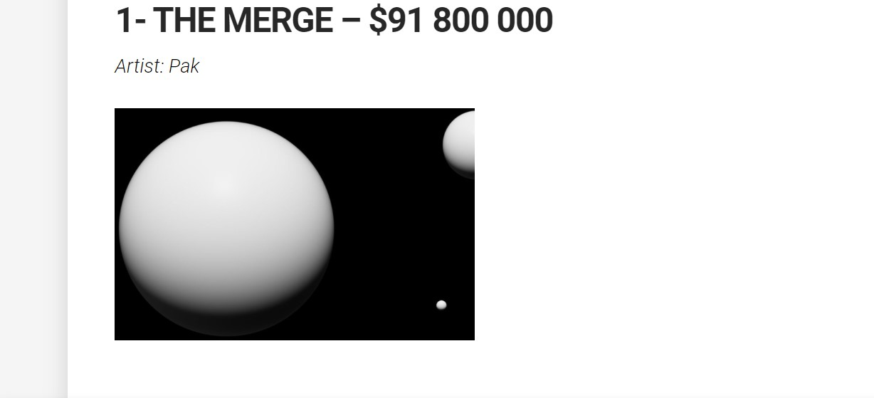

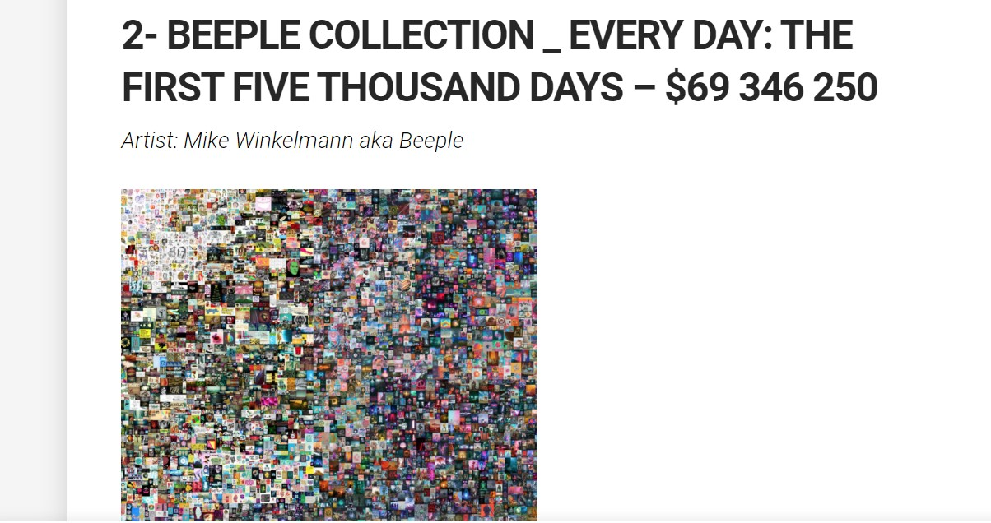

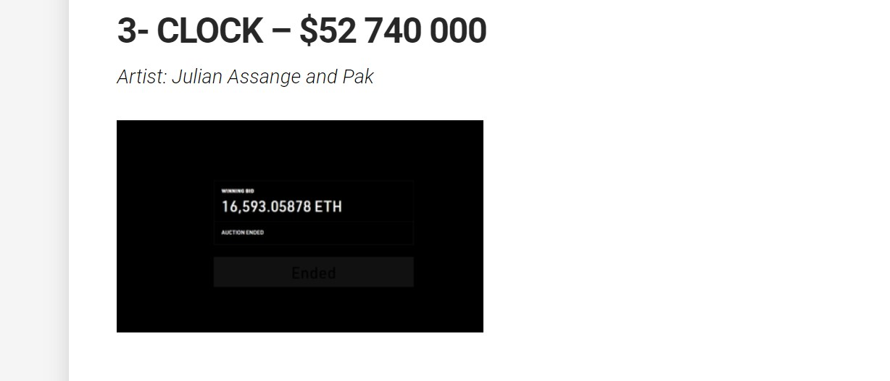

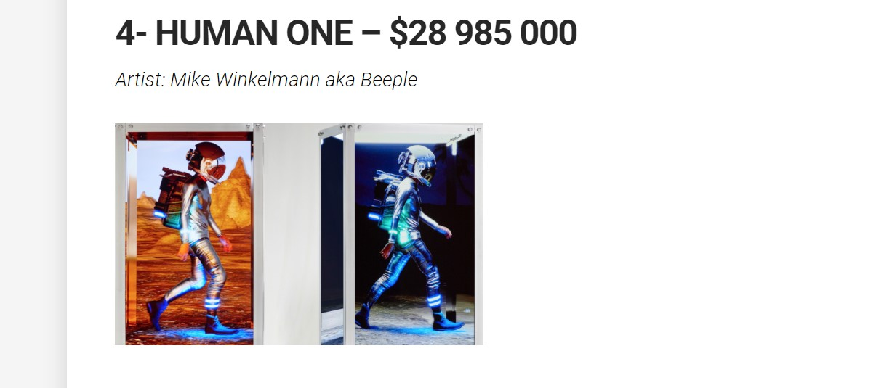

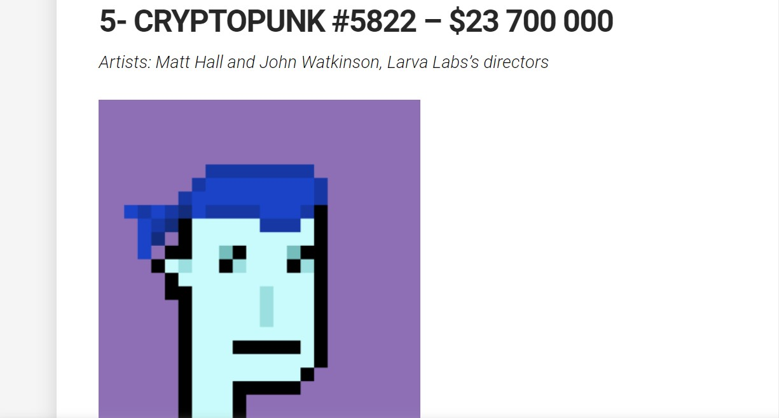

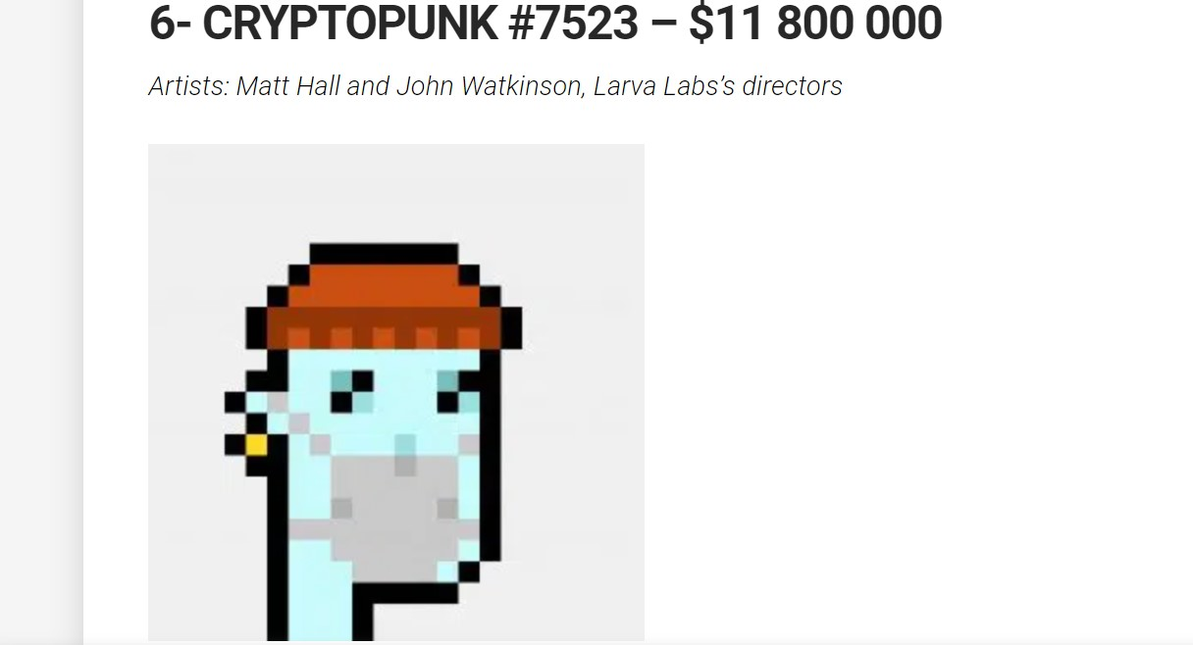

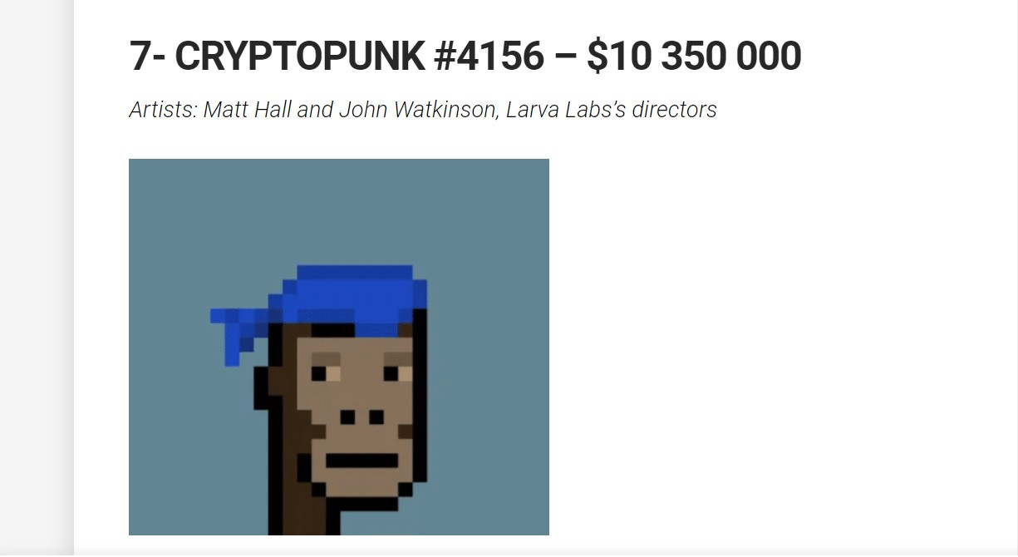

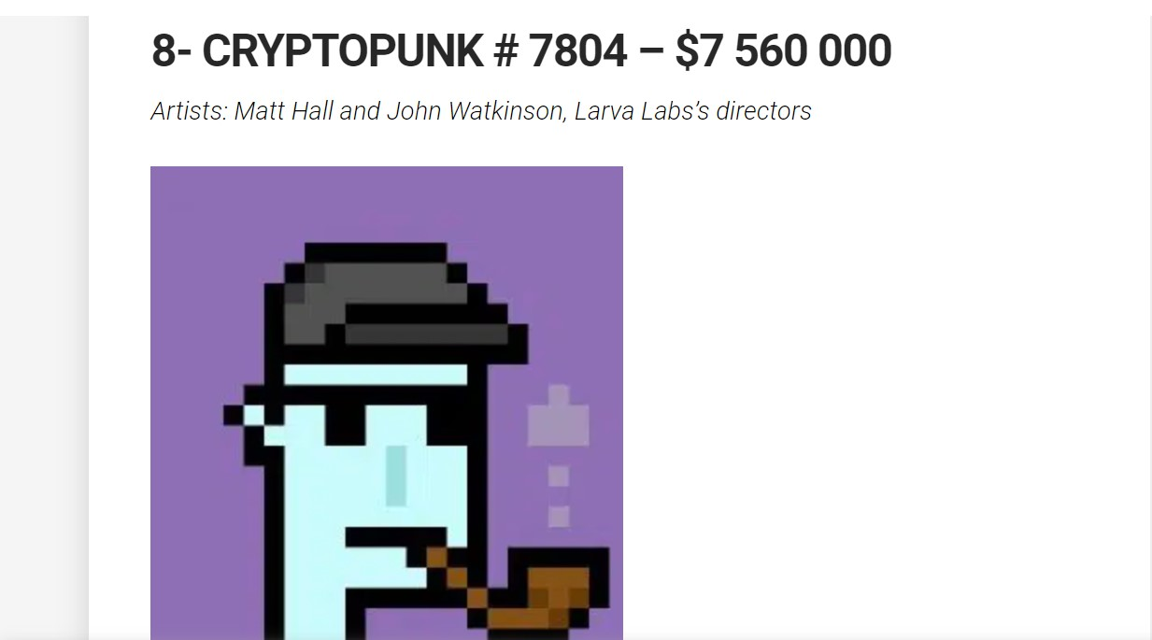

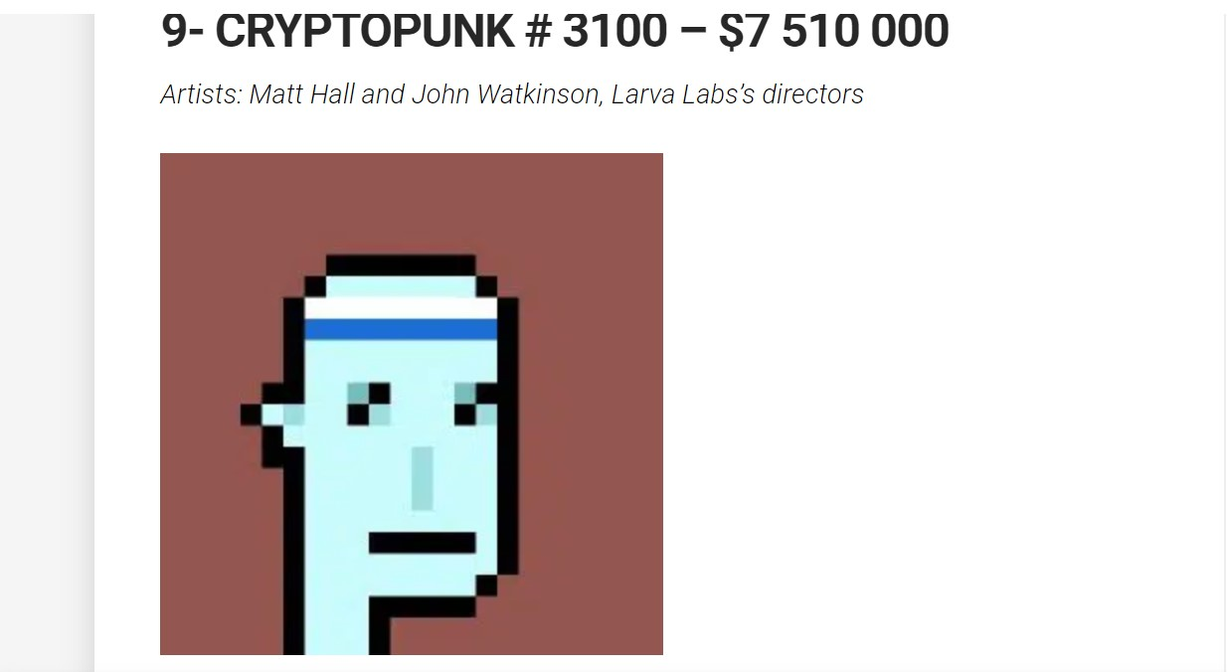

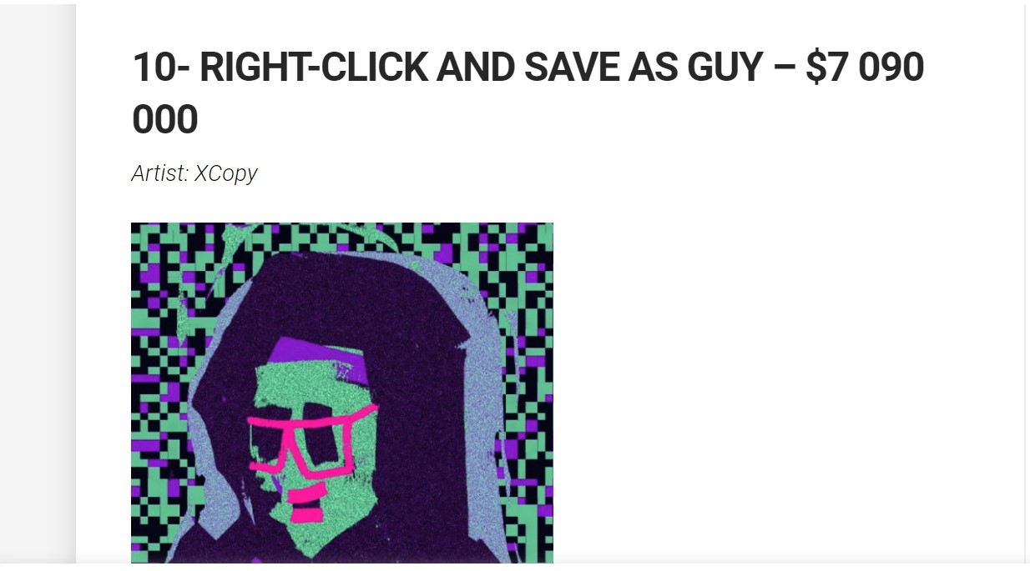

**Will NFT be successful?**

According to the study, **global transactions related to NFTs will escalate from 24 million in 2022 to nearly 40 million by 2027**. One of the top catalysts to push NFT adoption will be those linked to metaverse use cases, according to the study. This niche of NFTs will be the fastest growing in the next five years

**Future of NFT market?**

**The NFT industry is expected to grow steadily over the forecast period, recording a CAGR of 33.4% during 2022-2028**. The NFT Spend Value in the country will increase from US$13353.4 million in 2022 to reach US$68558.5 million by 2028. In Europe, the NFT market witnessed significant growth recently.

**The future of NFT:**

NFTs will boost more independence, allowing artists to create items and sell to their audience without waiting for long processes. Even students, once they come out of grad school, will not have to wait to get employed, but, due to this independent capability, be able to creatively create digital goods or engage in freelancing. This will also reduce unemployment rates in different parts of the world.

Additionally, these digital assets will play a role in the metaverse, boosting digital identity, items authentication, AI NFTs, personal health data monetization, business, secure transaction platform, true win-win technology, smart contracts, art selling, tickets, events, virtual worlds, and digital commerce.

Through NFTs, artists will have more control over the work they produce without depending on corporate forces or intermediaries. These artists can connect easily with customers and sell their work directly to customers. NFTs will provide access or ownership to unique items. These digital assets can play a huge role in solving the issues in the insurance sector, reducing all forms of fraud. They will also allow creators and artists to own their content and data.

The future of NFTs seems promising. In 2021, NFTs had a market size of approximately $41 billion, catching up to that of the traditional art market. Young people, freelancers and artists will greatly benefit from the growth of NTFs. The buying and selling of goods will be much easier.

NFTs will be a game changer. They require the implementation of different strategies and investors to turn this prediction into a reality. Many professionals in the healthcare sector, architects, designers, educators, and other industries will greatly benefit from the emerging technology. Students will learn things practically instead of relying on the theory part of books.

Schools need to start teaching students about the future of the digital world. Our children should know about the metaverse, NFTs, blockchain, and other digital technologies that are set to become game changers in years to come.

**Pros and cons of NFT:**

* Advantages of NFTs include **fractional ownership of assets, royalty payments to the NFT creator, safe technology, and efficient sales**.
* Disadvantages of NFTs include high minting costs, volatile pricing, and a high prevalence of imitation projects and fraud.